Problem Statement 1 : Write a Java program, to take a HDFS Path as input and display all the files and sub-directories in that HDFS path. 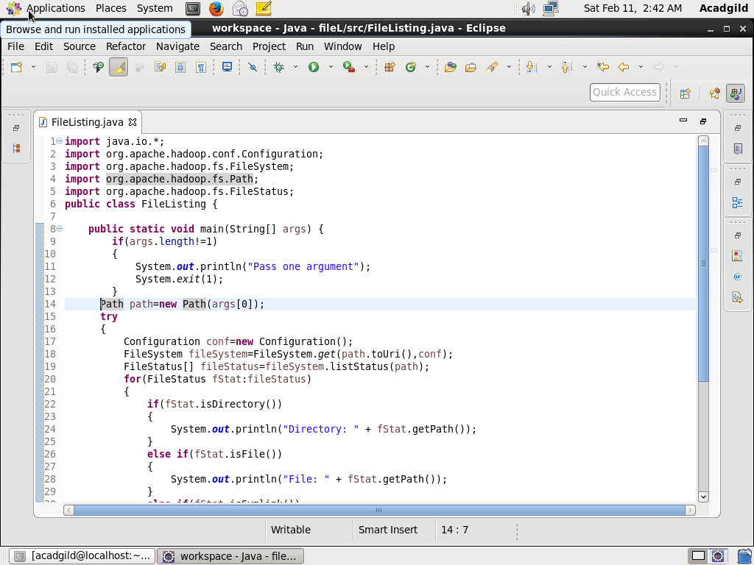

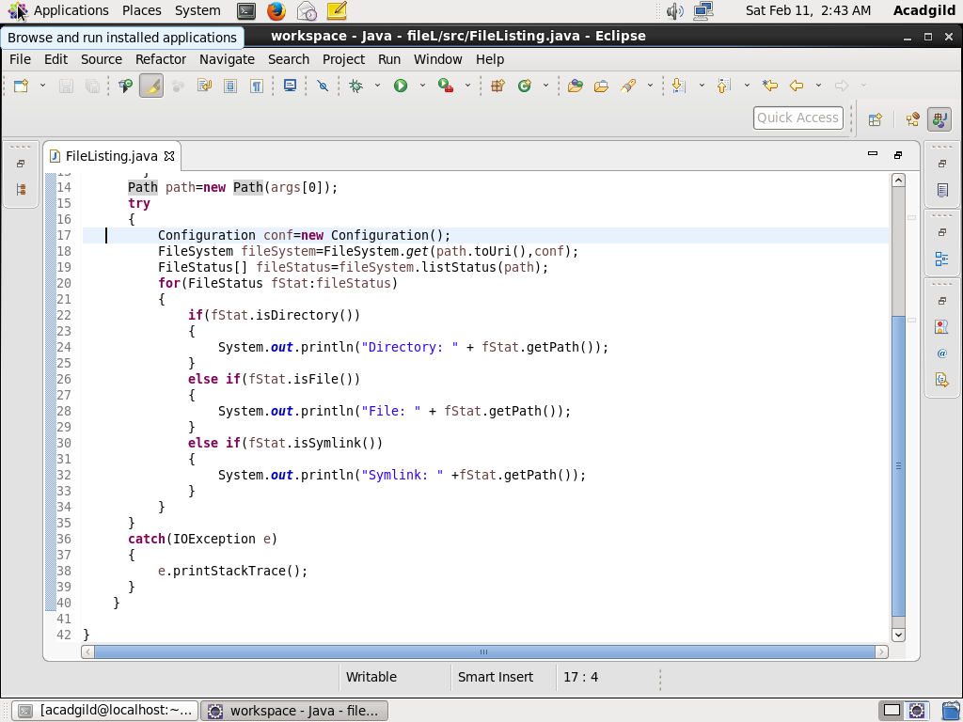

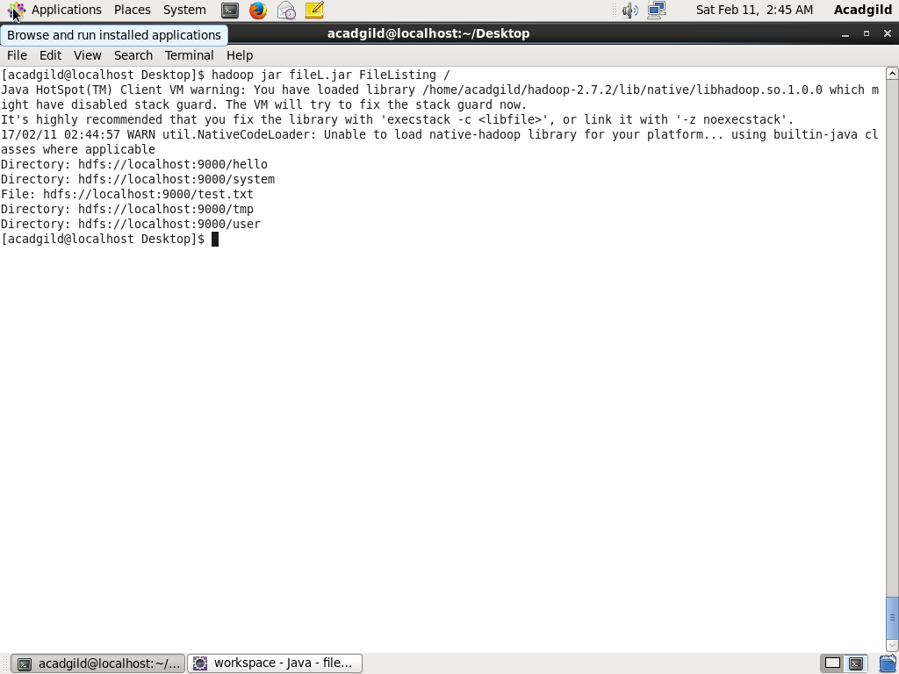

Problem Statement 2 : Modify the previous program to list all the files and sub-directories in the HDFS path recursively. 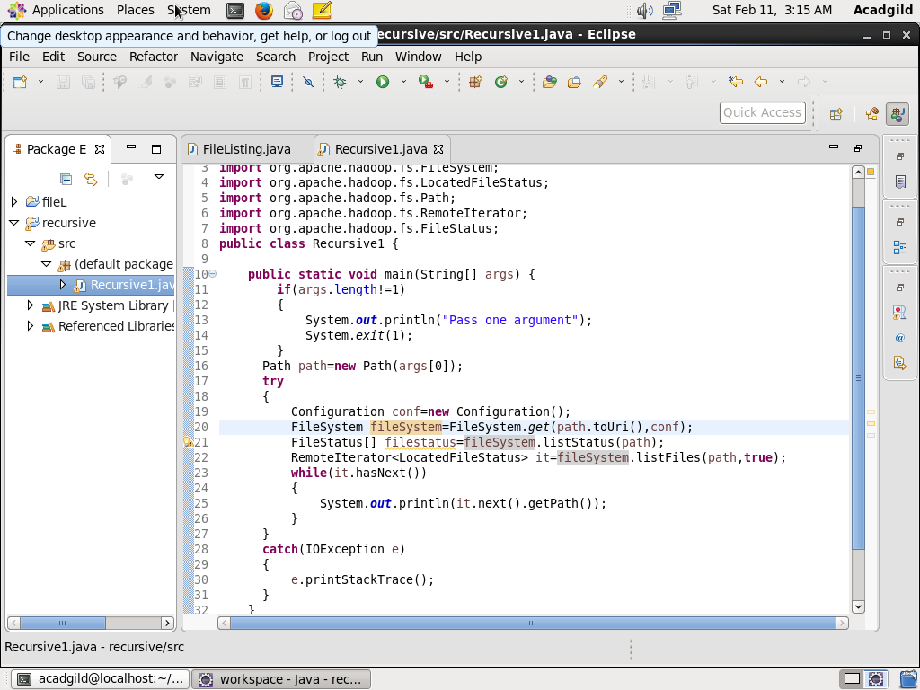

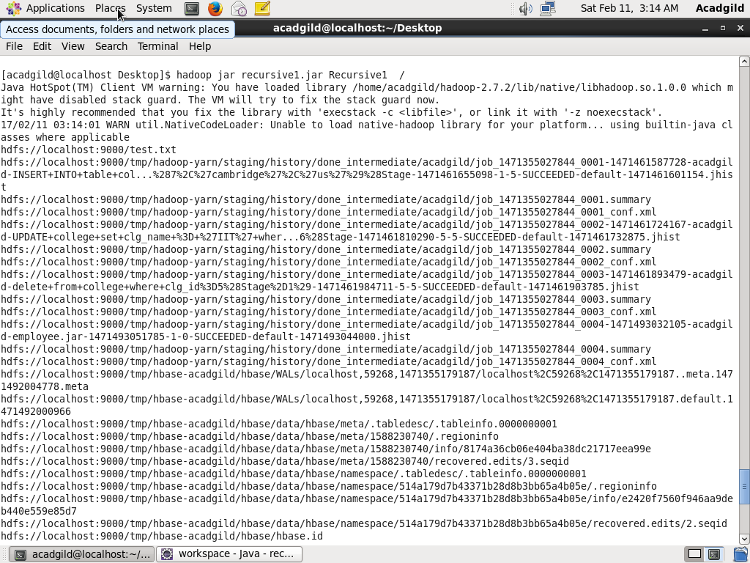

Problem Statement 3 : Modify the previous program to take multiple HDFS paths (separated by space) and list all the files and sub-directories in those HDFS paths recursively.

